AY2013 International Career Program

International Career Seminar
（国際実務英語）

Worksheets and Final Report Format

☆Deadline: Tuesday, October 1st, 17:00 p.m.

☆Place：To the Report Box of Nanako SHIMIZU
(Faculty of International Studies, A-building, 1st floor)

宇都宮大学 | 学部 学科 年
学生番号
氏 名

Presenter Profiles

Presenter Profile
Andrew Reimann
Faculty of International Studies, Utsunomiya University


Information
Andrew Reimann is from Vancouver, Canada and has a Ph.D. in Applied Linguistics from Macquarie University. He teaches classes on Comparative Culture Studies and Intercultural Communication. His research interests include raising cultural awareness and communication strategies. His recent publications include; Context, Culture and Communication, Culture Studies Handbook and Raising Cultural Awareness as part of EFL Teaching in Japan.

Career Path
Andrew first realized the importance of intercultural communication in kindergarten when he discovered that Canadian people spoke mostly English and not German. Growing up in a bilingual family as well as a bilingual and multicultural country, he discovered that communication was more about flexibility and negotiating meaning than grammar and pronunciation. By chance he was first given the opportunity to be a teacher in Mexico at the age of 19. This was a life changing experience, after which he went back to school to study Applied Linguistics. As a volunteer teacher for Canadian immigrants he learned about diversity and the realities of multiculturalism. Canada’s modern policies of tolerance and acceptance were born of a dark history of discrimination, racism and exclusion. It is only through understanding and accepting this failure that learning is possible and progress can be made. Differences in this way change from barriers and obstacles to opportunities and resources. As a coordinator of a language school in Montreal he found that education is also business and a teacher is a sales person. Communication requires mutual respect identifying with your audience and appealing to their needs and interests in order to exchange ideas that will spread. All students are customers. During his career in Japan he has taught every level from ‘baby society’ and kindergarten to university and the senior community. His students have ranged in age from 6 months to 101 years old. This has taught him more than can be put into words. Raising cultural awareness has been a central theme in this journey and continues to be the focus of research and lectures, aimed towards creating a functioning global society with more inclusive perspectives and an integrative worldview.

Notes
Key Note Profile | Local Challenges for Global Success
What are the most important skills needed to be successful in today’s world? Globalization offers opportunities for visionaries and those able to challenge new ideas. Success in this rapidly changing world requires being able to adapt, predict, improvise and pioneer new ideas while challenging old ones. At the core of this skill set is an awareness, understanding and acceptance that differences, risk or uncertainty are not obstacles but resources.

Outline
- Identity, purpose, initiative, and success
- Heroes, Role Models and Mentors
- Risk, Failure and Experience; How to challenge yourself.
- 3 stories of challenge and opportunity.
- Contrastive vs. Inclusive Perspectives

Key Words
Diversity | Creativity | Curiosity
Individuality | Empathy | Perspective
Inclusive/Contrastive | Initiative | Innovation

Key Questions
What is your 5 year plan?
What are the 3 most important things you have to do in the next 6 months?
What are 3 things you cannot leave home without? How do they enable/disable you?
What would you attempt to do if you knew you could not fail?
Who are your heroes/role models?
What is something new you could challenge to do for 30 days?
What is a foreigner? Why do we use this word and what do we mean?

References & Required Reading
Friedman, G. (2009). The Next 100 Years. A Forecast for the 21st Century.
Isaacson, W. (2011). Steve Jobs, A Biography.
Kashiwagi, A. and Carlysle, C. (2007) Why Apple isn’t Japanese. Newsweek, December 10, 2007.
McNeil, D. and Matsumoto, C. (2009) Students give job-hunting system a big F. Japan Times, Friday,
December 18th, 2009.

Keynote Worksheet

Presentation is a form of communication which requires feedback and participation in order to be successful. Listen carefully to the presenter. Take notes regarding important points and keywords. Make a list of comments you have as well as any questions. It is important for both the speaker and the audience to engage the subject through questions. Asking questions is also a sign of respect and appreciation.

Notes and Keywords

Comments

Questions

What are the 3 most important things you have to do in the next 6 months? List them in order of priority.
1) | 2) | 3)

What are 3 things you cannot leave home without? How do they enable/disable you?

What is something you can do to experience risk?

What is your 30 day challenge?
How confident are you that you can actually do it?
0% | 25% | 50% | 75% | 100%
Explain:

Who are your heroes/role models?
What are their qualities? How can you emulate them?

What is your career perspective? What skills are important? What do you have already? What do you need?

What is your global and local perspective?


Presenters Introduction
Each presenter will describe their career path. Take notes and write down comment, keywords or questions.

Bernard Timothy Appau
Keywords

Comments

Barbara Morrison
Keywords

Comments

Ana Sueyoshi
Keywords

Comments

Linda Ohama
Keywords

Comments

Yukiko Nakagawa
Keywords

Comments

Kaoru Nemoto
Keywords

Comments

Panel Discussion Worksheet

Topics

Main Ideas

Keywords

Key Questions

Comments

Work Group Materials
Use the charts to organize your information into logical arguments and evidence to support a main idea.
Content
My Opinion
Developing Ideas
Main Ideas | Examples | Support
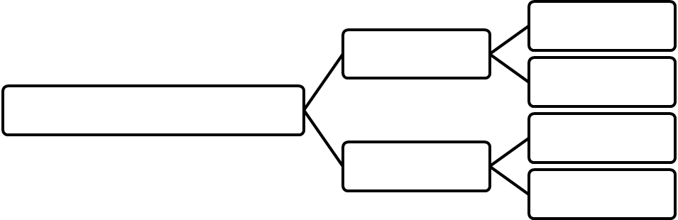
Main Ideas | Examples | Support
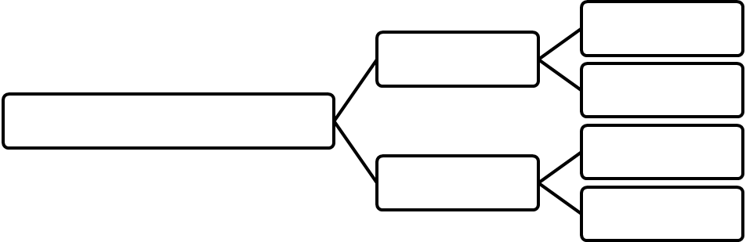
Main Ideas | Examples | Support
Work Group Materials

Main Idea
Support
Making Connections


Key Words
Key Questions

Presentation Planning Materials: Storyboard
Use the following pages to plan and design your presentation. The story board will help you connect your visual message with your content. Design your visual message while considering its purpose in supporting your presentation and how it relates to your verbal message. Consider the following questions:
- What is the purpose of each image, chart or graph? What will you say about them?
- Do they contribute to or distract from your overall message.

Introductory Slide

Visual Message

Verbal Message
Opening

Background

Hook

Connection

Main Idea

Purpose/Goal

Conclusion/Transition

Main Ideas and Supporting Slides (Example, Explanation, Description)

TRANSITION TO 1ST MAIN IDEA

Main Idea (Visual) | Main Idea (Verbal)
TRANSITION

Support (Verbal) | Support (Visual)
TRANSITION

Support (Verbal) | Support (Visual)
TRANSITION

Support (Verbal) | Support (Visual)
CONCLUDING TRANSITION

TRANSITION TO 2ND MAIN IDEA

Main Idea (Visual) | Main Idea (Verbal)
TRANSITION

Support (Verbal) | Support (Visual)
TRANSITION

Support (Verbal) | Support (Visual)
TRANSITION

Support (Verbal) | Support (Visual)
CONCLUDING TRANSITION

TRANSITION TO 3RD MAIN IDEA

Main Idea (Visual) | Main Idea (Verbal)
TRANSITION

Support (Verbal) | Support (Visual)
TRANSITION

Support (Verbal) | Support (Visual)
TRANSITION

Support (Verbal) | Support (Visual)
CONCLUDING TRANSITION

Concluding Slide
Go over and revise your storyboard. Make sure the slides flow logically and support your overall message visually and verbally. Can the audience easily follow or understand your support or examples? Consider the following questions:
- Is each image absolutely necessary? Are they simple and easy to understand?
- Do they support my goal? Are they relevant to my verbal message?
- Is my conclusion clear, logical and memorable?

Visual Message

Verbal Message

Opening Transition

Connection

Summary

Final Message

Conclusion

Presentation Rehearsal: Comments and Feedback
Take notes and ask questions about each presentation. Give feedback and comments.

Presentation 1
Comments & Questions

Presentation Comments and Feedback
Content
Attitude
Visuals
Language
Connections

Presentation 2
Comments & Questions

My Presentation Comments and Feedback
Content
Attitude
Visuals
Language
Connections
Final Presentation Evaluation
Make comments and evaluate other group’s presentations using the checklists below.
Group | ( ) | ( ) | ( ) | ( ) | ( )
Topic

Content

Attitude

Visuals

Language

Connections

Comments &
Questions
Seminar Summary
- What did you learn during the Career Seminar?

- What is your action plan to develop your career?

- What are your comments or suggestions for the next seminar?

Self Evaluation
Reflection means looking back. Look back at the Career Seminar and think about your level of participation.
Use the scale below to reflect on your use of English.
1 = not at all (0%) | 2 = a little (30%+) | 3 = quite a bit (65%+) | 4 = a lot (up to 100%)

I spoke English as much as possible.
1 | 2 | 3 | 4
Explain:

I tried to participate in presentations and lectures.
1 | 2 | 3 | 4
Explain:

I was able to make comments and ask questions.
1 | 2 | 3 | 4
Explain:

I used English during the workshops.
1 | 2 | 3 | 4
Explain:

I used English to talk to other members of the seminar.
1 | 2 | 3 | 4
Explain:

I was able to exchange ideas with others.
1 | 2 | 3 | 4
Explain:

I will be able to apply what I learned at the Career Seminar to my future.
1 | 2 | 3 | 4
Explain:

How useful was the international career seminar?
1 | 2 | 3 | 4
Explain:

Presentation Summary
The presentation summary is submitted by the group leader. Each group submits only one summary.

